My name is… | Photo | I like…
I am …………… years old |  | 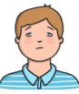  I don’t like…
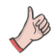  I’m really good at… |  | 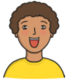  I am excited about…
I sometimes need help with…  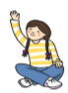 |  | 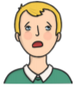  I am a bit worried about…
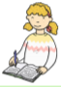  It helps me to learn when… |  | 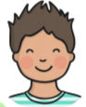  I am looking forward to…

