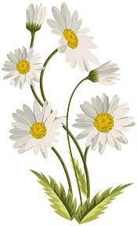
CAVERSHAM
HORTICULTURAL
SOCIETY
AUTUMN SHOW
2022

Saturday 10th September
2.00pm to 4.30pm
Emmer Green Primary School

Children and adult show classes.

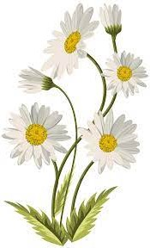
Why not show off your skills by entering one of the many classes of fruit, flowers, vegetables, baking and handicrafts ?

Silver Cups to be won!

Discover more about the autumn show and the society on our website and Facebook page:
www.caversham-horticultural.org.uk
www.facebook.com/CavershamHorticulturalSociety
